Title: What spurs growth and Innovation in developing countries? Case study of India

Abstract 5%

This paper seeks to answer the question of what spurs growth and innovation in developing countries. By taking a look at data on capital inflows, aid, and even the ease of doing business index, compiled by the world bank, we are able to examine historical measures of output and productivity such as the gdp by sector, and sectoral allocation of the workforce, as well as increases in patents over time.

Intro 20%

One of my earliest awakenings to the economy and economic output of a country lay in examining the CIA’s world factbook resource, as part of a cultural anthropology class. I recall looking at pie charts and distributions of the gdp by sector, and then looking at the distributions of the workforce by sector and wondering to myself. We’d been taught about what the primary, secondary, and tertiary sectors were.

I’d known that a services based economy was preferable to manufacturing, and that capital intensive agricultural production was preferable to labor intensive agriculture.

My teacher was likely Goan, Indian, and I was taking electives at a community college in California prior to transferring. Whereas other economic questions about ‘where banks made their margins?’ plagued me as a child, as a college student, I was apt to raise the question of how the distribution of FDI affected both parties involved. This is still a difficult question to address when externalities are tangled in.

Other statistics such as India’s 70% of population living in rural areas, and the rest in urban areas was another gripping statistic that stayed with me. From there on forth, I started investigating concepts such as the human development index, and early notions of human capital, and have continued to pay close attention to the forces of innovation, and the environments in which they thrive.

Lit Review 10%

Today’s paper stems largely from a motivation springing from a largely untalked about book, by the name of ‘small is beautiful: economics as if people mattered’. In it, the author makes the argument, that instead of the leapfrogging we so often hear about with regards to the third world, we will have to scale back innovations a notch when transplanting them from the first world to the third world.

In simple terms, this is a problem of innovation in the first world, vs. adoption in the third world. What is likely to spur innovation in the third world? And is a simple jump in economic growth stemming from capital creation enough to prepare the ground for innovation in the third world? Can we automatically infer that increased economic productivity implies increased innovation?

Some of the existing literature we draw upon are, aside from E.F. Schumacher’s Small is Beautiful (1973), are Raj Chetty’s 2018 paper on innovators in America, and Adam Grant’s Originals, from 2017.

Moreover we draw partially on Robert Atkinson’s work on Innovation Economics, from 2012. Other players in the field include Fan, Peilei (2008). Innovation Capacity and Economic Development : China and India. UNU-WIDER., the Global innovation index, published by Cornell and INSEAD, and Chris Freeman’s 1990 paper on the Economics of Innovation.

Data 20%

It is no surprise that regimes and relative political freedom play a crucial role in business innovation and industrial production. However, here we restrict our attention to capital inflows, and FDI.

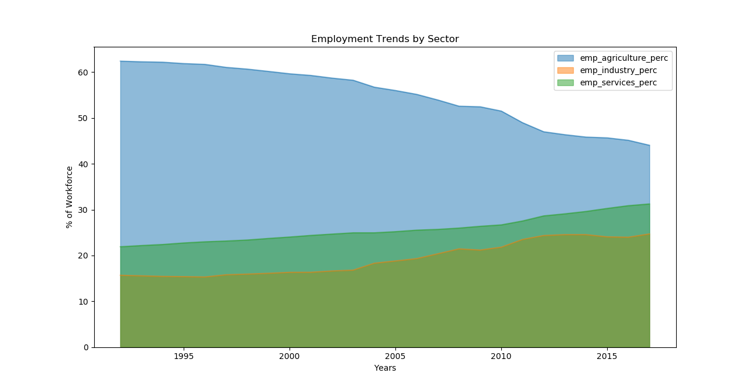

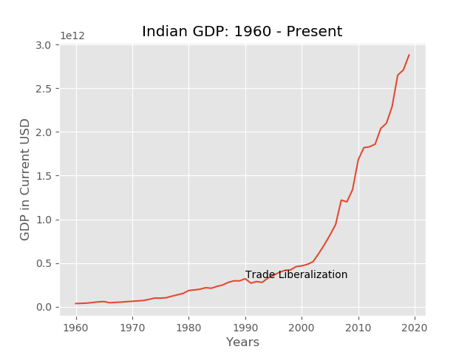

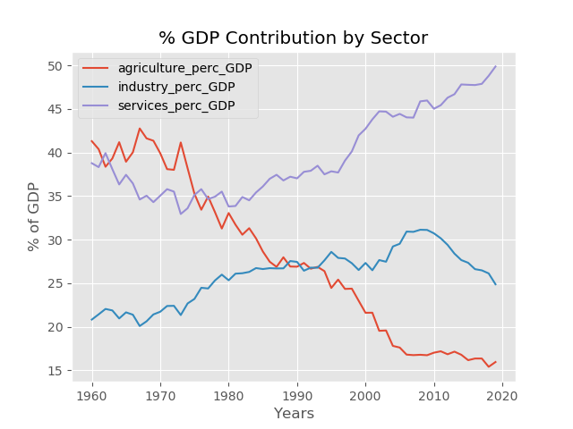

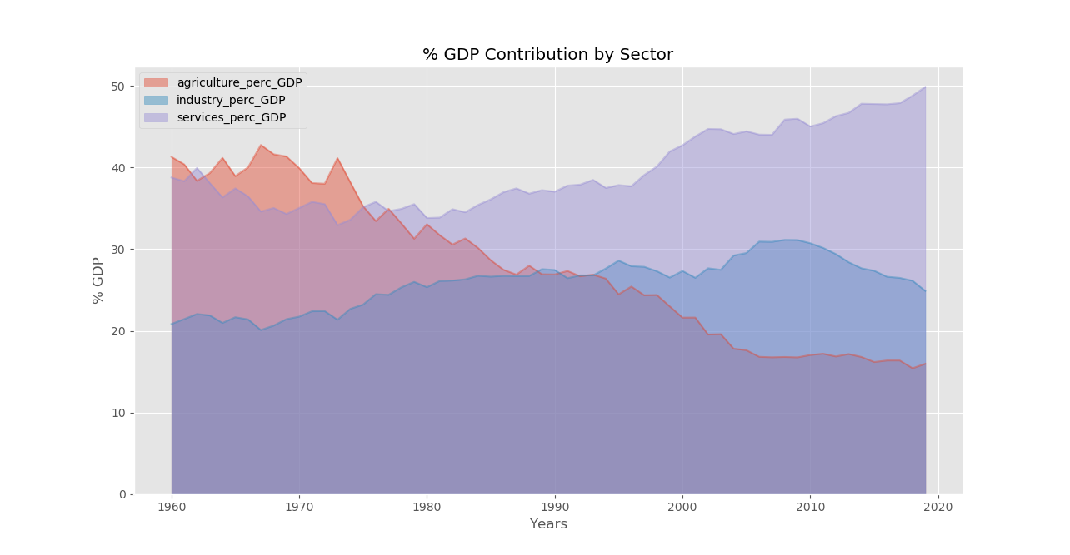

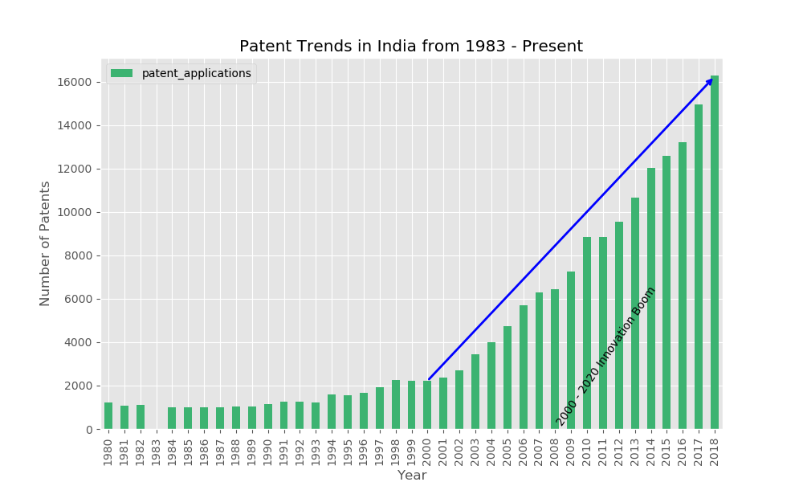

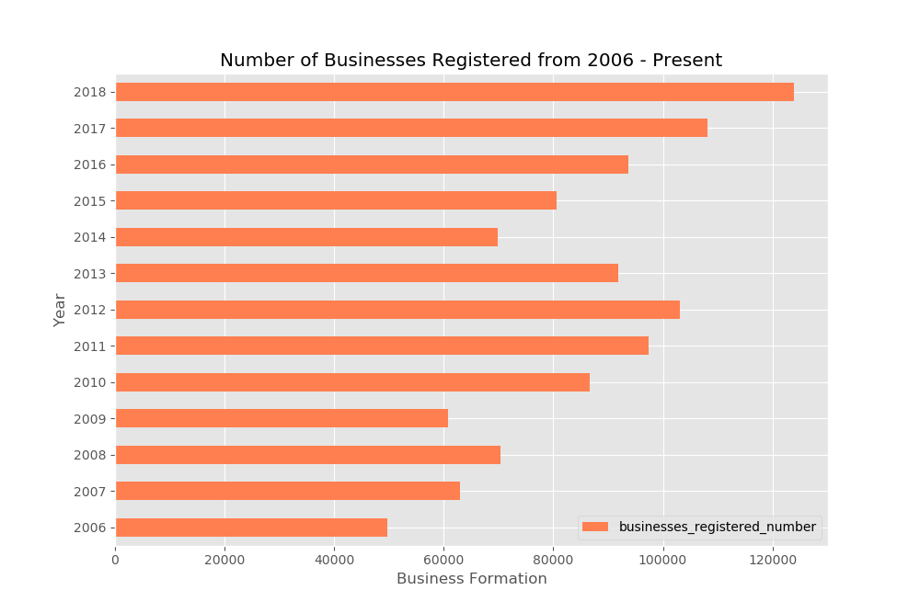

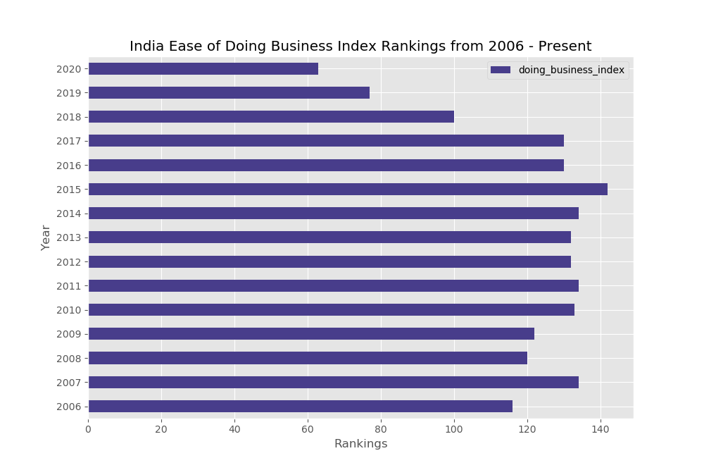

Results 30%

Our results show that post economic liberalization in India there was

1. A steep incline the GDP increase from 1990 onwards
2. A steady stream of innovation from the early 2000s up until the present
3. A sharp incline in the numbers of business formation for the past 5 years, from 2015 up until the present
4. An amenable change in the ease of doing business, and a jump in the rankings from 2015 up until the present

Conclusion 15%

Ascribing these changes to Modi’s conservative consolidated government may be a bit hasty. As liberals who are not exposed to the social conditions on the ground, we are immune to the social strife and distress present for parties compromised. Conformity is valued over diversity.

But the numbers indicate that business is growing. This is an age-old tale of assimilation being in everyone’s best interests. But it strikes deepest at the hearts of compromised parties and cultures.

India is currently having to deal with the upheaval associated with the majority group setting the economic agenda.

Minorities feel neglected and uncared for.

Outright violence occasionally breaks out, and it breaks the hearts of those of us who have reputable minorities for friends, and rub shoulders with other minorities regularly.

But we hope that we get past this period of distress, to a point where the social agenda is no longer questionable, and where economic advance becomes the priority. Where upward mobility becomes more accessible, and goals are agreed upon.